PROGRAM 1

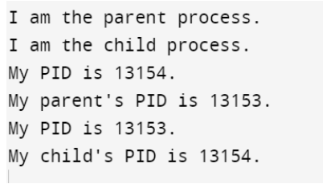

PROGRAM 2:

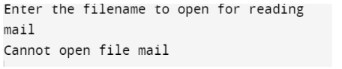

PROGRAM 3:

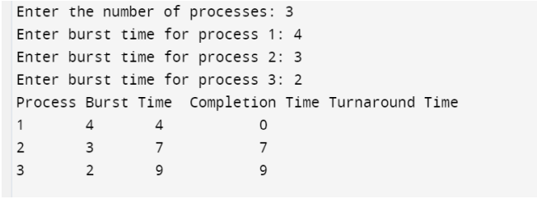

PROGRAM 4:

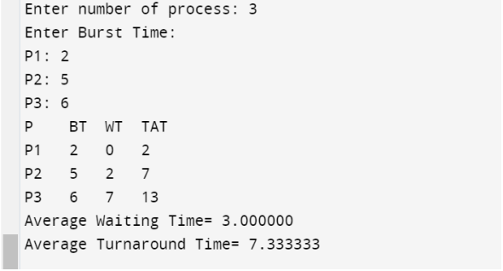

PROGRAM 5:

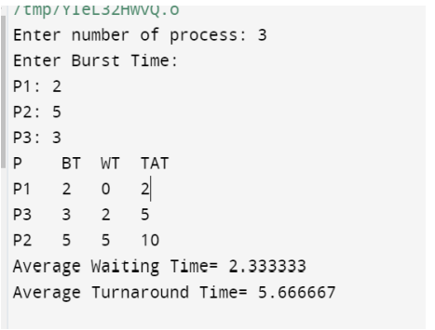

PROGRAM 6:

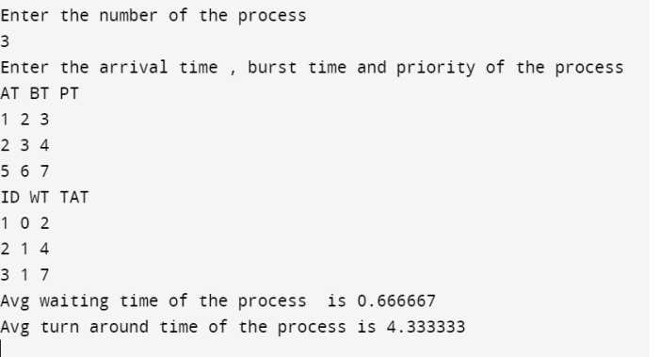

PROGRAM 7:

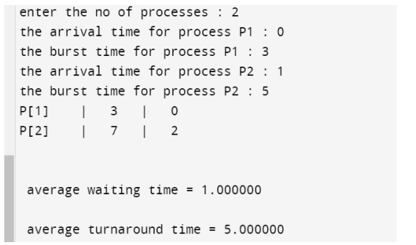

PROGRAM 8:

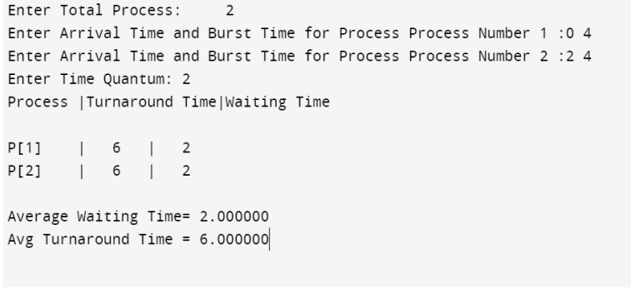

PROGRAM 9:

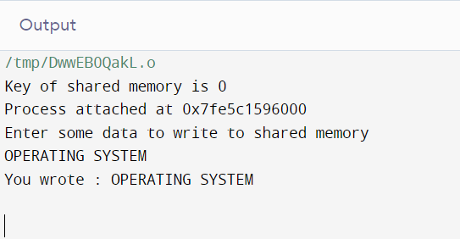

PROGRAM 11:

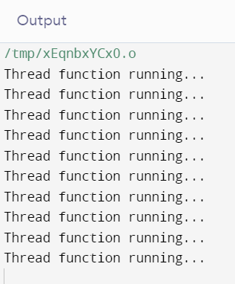

PROGRAM 12:

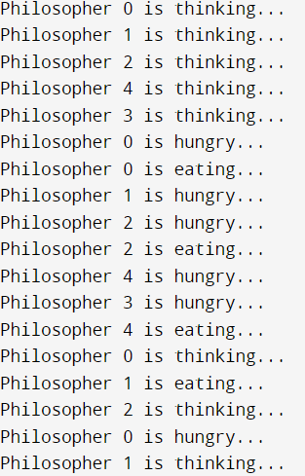

PROGRAM 13:

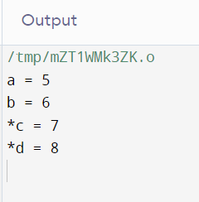

PROGRAM 9:

PROGRAM 10:

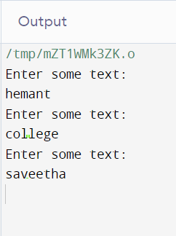

PROGRAM 14:



PROGRAM 15:

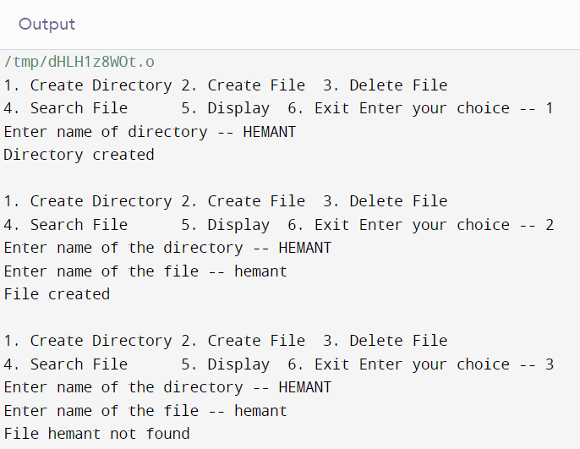

PROGRAM 16:

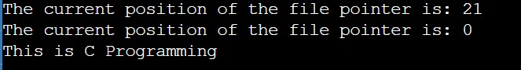

PROGRAM 17:

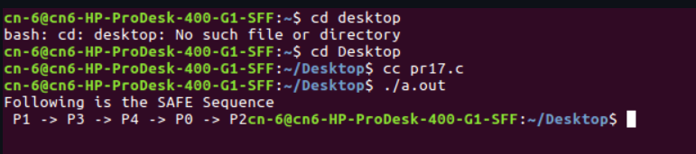

PROGRAM 18:

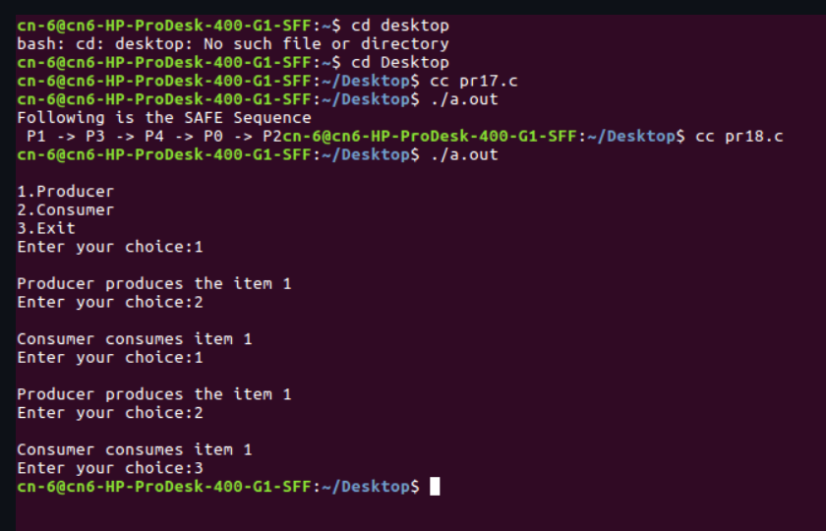

PROGRAM 21:

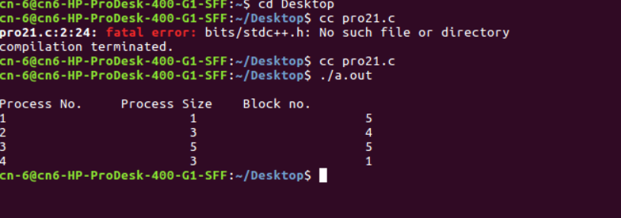

PROGRAM 22:

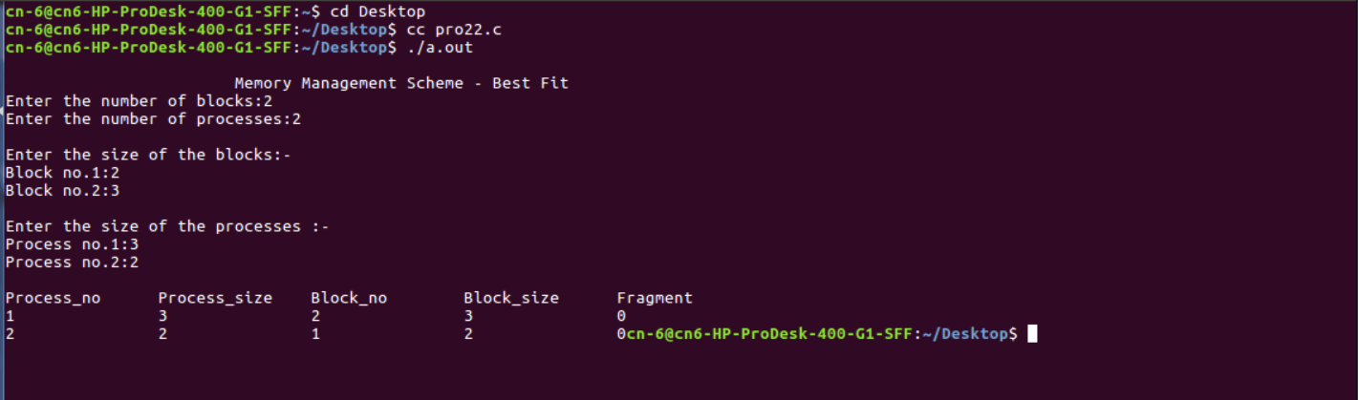

PROGRAM 23:

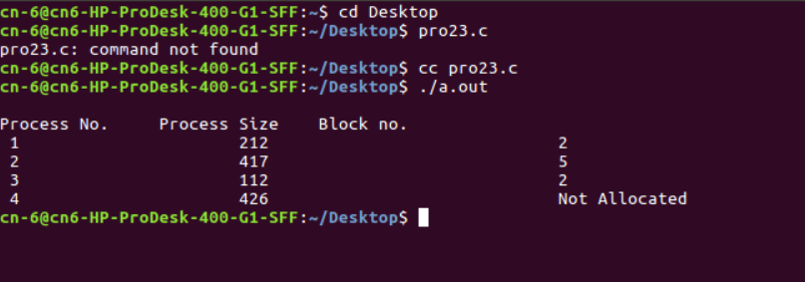

PROGRAM 24:

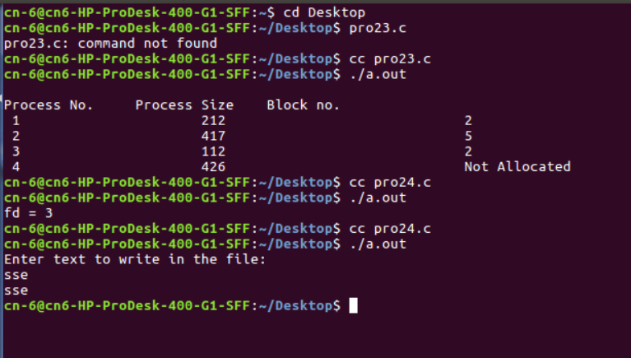

PROGRAM 26:

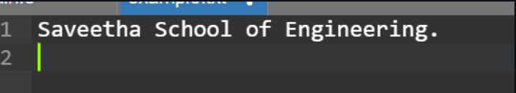

PROGRAM 27:

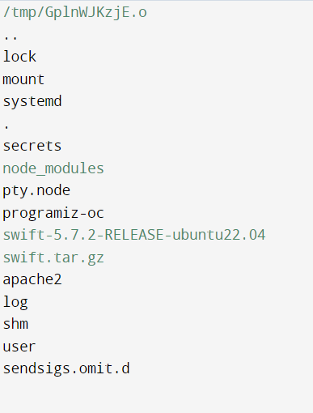

PROGRAM 28:

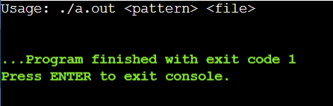

PROGRAM 29:

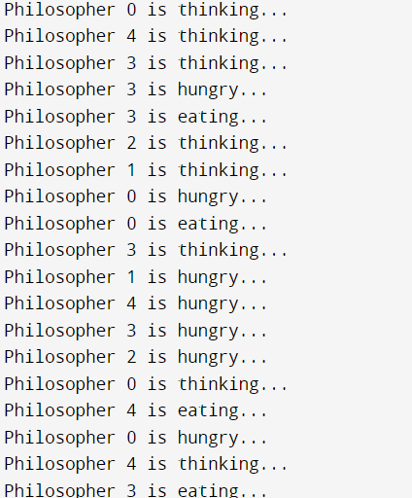

PROGRAM 30:

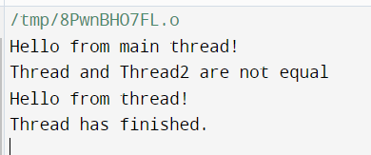

PROGRAM 31:

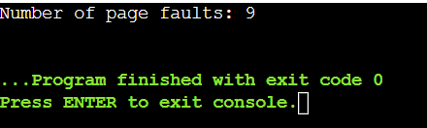

PROGRAM 32:

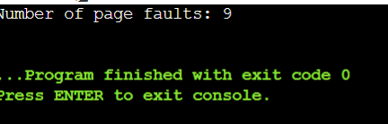

PROGRAM 33:

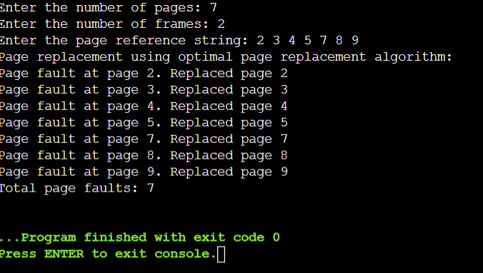

PROGRAM 34:

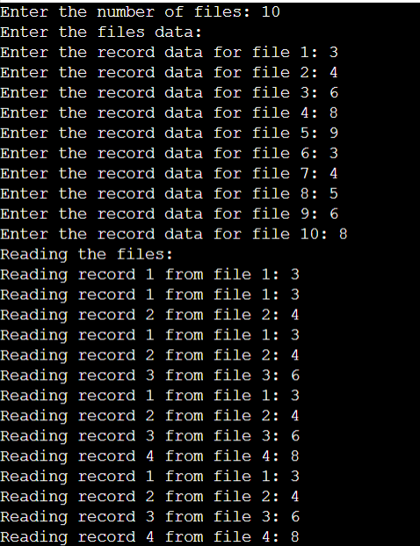

PROGRAM 35:



PROGRAM 36:

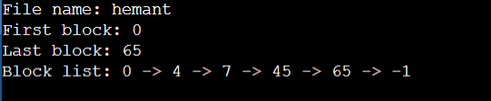

PROGRAM 37:

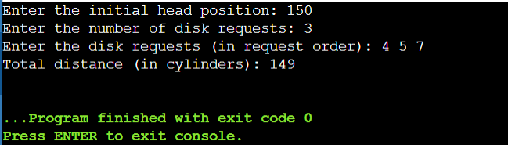

PROGRAM 38:

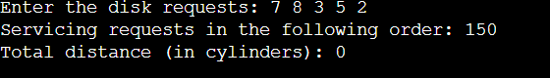

PROGRAM 39:

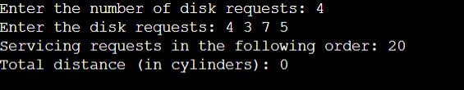

PROGRAM 40:

